Nalongsone Danddank Student ID : 14958950 StarID: jf3893pd

Email: [nalongsone.danddank@my.metrostate.edu](mailto:nalongsone.danddank@my.metrostate.edu)\

**ICS 365. Organization of Programming Languages.**

**Programming Assignment 5**

**ProLog**

**Due**: See Syllabus

**Points**: 40

Format is: (base drug, interacts with drug, effect)

1. Given two medications, if they interact, tell what the effect of the interaction may be. Note there may be more than one result of the interaction.

Solution:

interaction_effect(Base_Drug, Interacts_Drug) :-

    findall(Effect, interacts(Base_Drug, Interacts_Drug, Effect), Result_List),

    write('The effect list of the interaction: '),

    write(Result_List), nl.

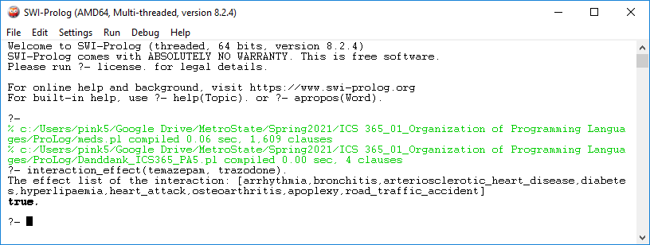

1. Given a medical condition, list the drug interactions that may have caused it.

Solution:

list_drug_interactions(Medical_Condition) :-

    findall(Interacts_Drug, interacts(_, Interacts_Drug, Medical_Condition), L),

    sort(L, Result_List),

    write('The list of the drug interactions: '),

    write(Result_List), nl.

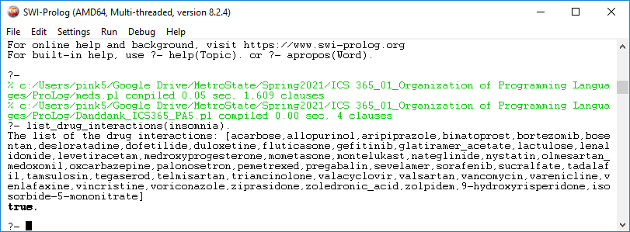

1. Given a drug, list the drugs, which have no interactions with it.

Solution:

list_no_interacts_drug(Drug) :-

    findall(Interacts_Drug, interacts(Drug, Interacts_Drug, _), L),

    sort(L, Uniq_L),

    findall(All_Interacts_Drug, interacts(_, All_Interacts_Drug, _), All_L),

    sort(All_L, Uniq_All_L),

    subtract(Uniq_All_L, Uniq_L, Result_List),

    format('The list of the drug with no interactions with ~w is: ', Drug),

    write(Result_List), nl.

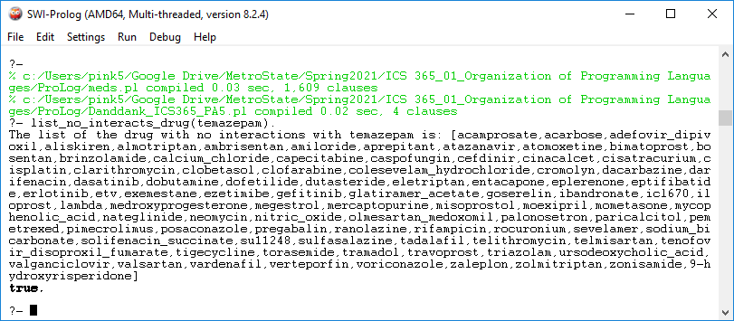

1. Given a drug, list the drugs, which do interact with it.

Solution:

list_interacts_drug(Drug) :-

    findall(Interacts_Drug, interacts(Drug, Interacts_Drug, _), L),

    sort(L, Result_L),

    format('The list of the drug with interactions with ~w is: ', Drug),

    write(Result_L), nl.

